Manuscript title (14 pt, bold, centre-aligned)
Author One^{a,} *, Author Two^{b}, Author Three^{c}
ª Affiliation One, Department, Institution, City, Country; ^{b} Affiliation Two, Department, Institution, City, Country; ^{c} Affiliation Three, Department, Institution, City, Country
* Corresponding Author: publish@glintplus.com

Abstract
Provide a concise summary (≤ 250 words) covering: (i) background & objective, (ii) methods, (iii) principal results and (iv) main conclusion. Avoid citations and undefined abbreviations.

Graphical Abstract
Insert a single, self‑explanatory image (width ≤ 15 cm) that summarises the study. Use clear labels, minimal text and ensure readability at 300 dpi. This graphic will accompany the online article and should entice potential readers.
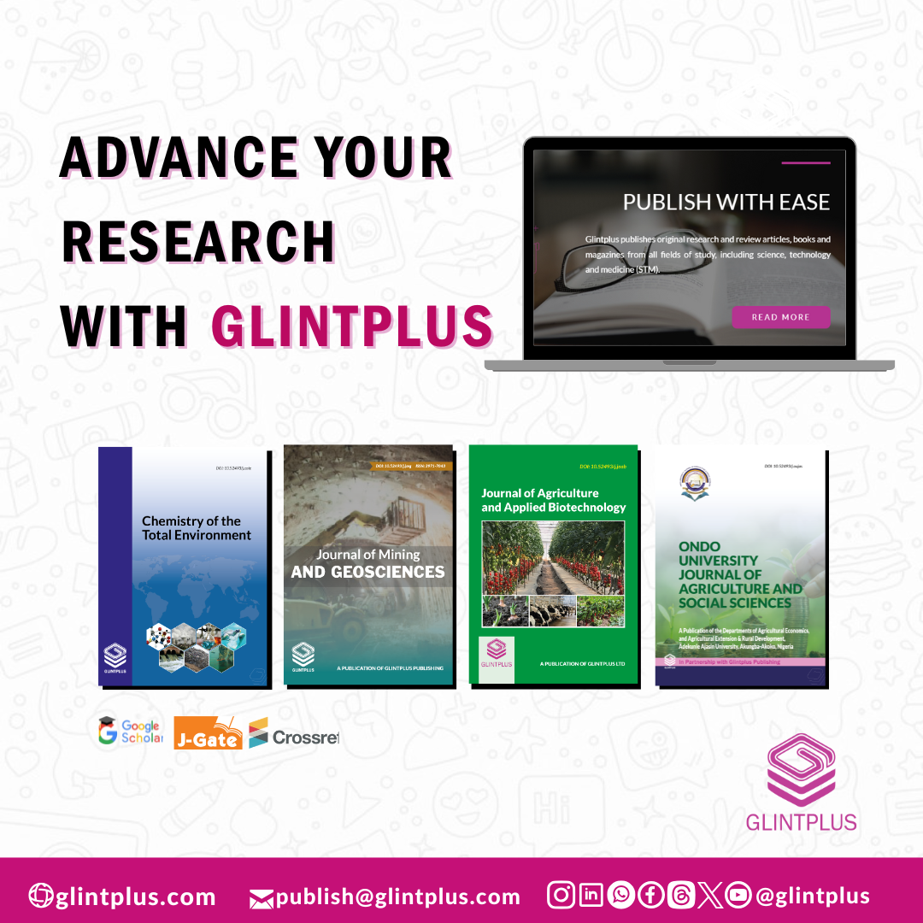
Graphic Abstract

Keywords
List 4–5 keywords separated by commas (use recognised indexing terms).

Highlights
Supply 3–4 bullet points (≤ 85 characters each) that convey the novelty and key outcomes of the work. These will appear in indexing services and help readers grasp the contribution at a glance. For example:
- Glintplus rapidly processes accepted manuscripts within days.
- Quality peer review by field specialists boosts scientific rigour and credibility.
- Global indexing & open access maximise your article’s reach and citations.
- Multidisciplinary journals span sciences, agriculture, mining & social sciences.

1 Introduction
Structure the introduction to logically guide the reader from broad context to specific aim:
- Background: Summarise existing knowledge and why the topic matters.
- Knowledge Gap: Clearly articulate what is unknown or controversial (the “gap”) that your work addresses.
- Objective/Hypothesis: State the precise aim or hypothesis.
- Significance: Briefly outline potential impact or application.

2 Materials and Methods (or Methodology)

2.1 Materials (Where applicable)
List reagents (including their suppliers), organisms, datasets, equipment (model & manufacturer, city, country). Use SI units throughout.

2.2 Methods
Describe ALL procedures with enough detail for reproducibility. Include controls, randomisation, blinding and ethical approvals where applicable.

2.3 Statistical Analysis
Specify software (version) and statistical tests. Provide criteria for significance (e.g., α = 0.05).

3 Results and Discussion
Present findings in a logical order, integrating interpretation immediately after each set of results. Support statements with figures/tables and literature comparisons. Avoid redundancy; focus on how results bridge the knowledge gap.
Display your data using well-formatted tables and clear figures. See examples below:
Table 1. Descriptive statistics of measured variables
Our Journals | ISSN | link
COTE* | 2971-7035 | glintplus.com/journal/index.php/cote
JAAB* | 2971-7051 | glintplus.com/journal/index.php/jaab
JMG* | 2971-7043 | glintplus.com/journal/index.php/jmg
OUJAS | 1595-6466 | glintplus.com/journal/index.php/ooujas
* indexed in JGate; all journals are indexed with Google Scholar and Crossref; DOIs available for all papers.

Figure 1. Call for manuscript submissions to the journals published by Glintplus Publishing.
Refer to tables and figures in‑text, e.g., “As shown in Table 1, …” or “Figure 1 illustrates …”.

4 Conclusion
Provide a concise synthesis of key findings linked to your objective and knowledge gap. Highlight the broader implications, limitations, and specific, actionable recommendations for future research or practice.

Acknowledgements
Thank individuals, institutions, and funding bodies. Mention ethical approval numbers if relevant.

Funding Statement
State funding sources and grant numbers or write “This research received no external funding.”

Conflict of Interest
Declare any conflicts of interest or “The authors declare no conflict of interest.”

Data Availability Statement
Indicate dataset repository, DOI, or licence.

CRediT Author Contribution Statement
Specify each author’s contribution using CRediT taxonomy (e.g., “AB: Conceptualisation; AB, CD: Methodology; CD: Investigation; AB: Writing—Original Draft; AB, CD: Writing—Review & EF: Editing; Supervision”).

References
Follow journal style. Example:
Author, A. & Author, B. (Year). Article title. Journal Name,Volume(Issue), pages. https://doi.org/... or valid link
Arowojolu, I. M., de Oliveira Alves, I., Benson, N. U., & Sodré, F. F. (2023). Microplastics in aquatic environments: A growing, unresolved concern. Chemistry of the Total Environment, 3(1), 8-22. https://doi.org/10.52493/j.cote.2023.1.76
Ikuemonisan, E. S. (2024). Determinants of career decisions among rural youth: the case of undergraduate students from farming households in Ondo State, Nigeria. Ondo University Journal of Agriculture and Social Sciences, 2(1), 9-27. https://doi.org/10.52493/j.oujas.2024.2.95
Konkwo, S. O., & Egbodion, J. (2024). Postharvest advisory competency and training needs of N-Power Agro Advisors in Benin metropolis, Edo State, Nigeria. Journal of Agriculture and Applied Biotechnology, 3(1). https://doi.org/10.52493/j.jaab.2024.1.97

